CptS 122 – Data Structures

November 7, 2016

Your Name: _____Elijah Andrushenko_______ TA’s Name: __Hunter Wilkes_______

ID#: ____011476324_______ Section #: ______08___________

# Take-Home: Quiz 7 (15 pts) – Inheritance in C++

1. **(5 pts)** What is inheritance? Explain.

Inheritance allows a class to have the same behavior as another class and extend or tailor that behavior to provide special action for specific needs.

www.webopedia.com/TERM/I/**inheritance**.html

1. **(2 pts)** Inheritance enables __software reusability_____, which saves time in development and encourages using previously proven high-quality software.

1. **(2 pts – 1 pt/each)** An object of a(n) ___derived_____ class can be treated as an object of its corresponding ____base_____ class.

1. **(2 pts)** Inheritance is representative of a(n) ___”is a”____ relationship. A Manager object demonstrates this relationship because it can be treated as an Employee object.

1. **(2 pts)** The following class diagram is an example of ____Multiple_____ inheritance.

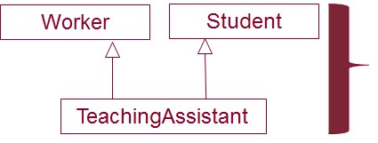

1. **(2 pts)** When an object of a derived class is instantiated, the base class’ __constructor__ is called implicitly or explicitly to initialize the data members of the base-class in the derived-class object.

Instructor: Andrew S. O’Fallon